How to Access Databases Using Python
- Python Ecosystem:
  - Packages: Numpy, Pandas, matplotlib, Scipy
  - Ease of use
  - Portable
  - Python supports relational database systems
  - Python Database API (DB-API)
  - Detailed documentation
- Jupyter Notebooks
  - Language of choice
  - Share Notebooks
  - Interactive output
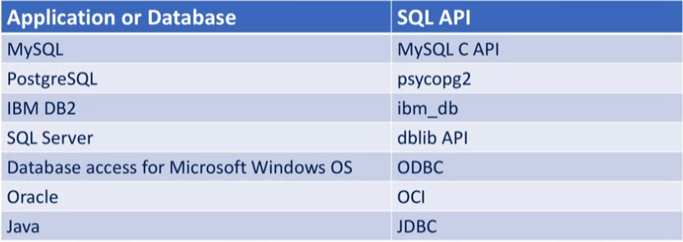
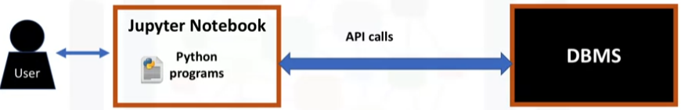
  - Big data integration

Writing code in DB-API
- DB-API
  - Easy to implement and understand
  - Similarity between python modules
  - Achieves consistency
  - Portable
- Concepts
  - Connection objects
    - Database connections
    - Manage transactions
  - Cursor Objects
    - Database queries
    - Scroll through results set
    - Retrieve Results
- Connection Methods
  - .cursor()
  - .commit()
  - .rollback()
  - .close()
- Cursor Methods
  - .callproc()
  - .execute()
  - .executemany()
  - .fetchone()
  - .fetchmany()
  - .fetchall()
  - .nextset()
  - .arraysize()
  - .close()
Connecting to a data base
- import ibm_db
- #Replace the placeholder values with your actual Db2 hostname, username, and password:
dsn_hostname = "2f3279a5-73d1-4859-88f0-a6c3e6b4b907.c3n41cmd0nqnrk39u98g.databases.appdomain.cloud"
dsn_uid = "kgm97129"
dsn_pwd = "az9as6m7j5EtkyEm"

dsn_driver = "{IBM DB2 ODBC DRIVER}"
dsn_database = "BLUDB"
dsn_port = "30756"
dsn_protocol = "TCPIP"
dsn_security = "SSL"
- dsn = (
"DRIVER={0};"
"DATABASE={1};"
"HOSTNAME={2};"
"PORT={3};"
"PROTOCOL={4};"
"UID={5};"
"PWD={6};"
"SECURITY={7};").format(dsn_driver, dsn_database, dsn_hostname, dsn_port, dsn_protocol, dsn_uid, dsn_pwd,dsn_security)

try:
conn = ibm_db.connect(dsn, "", "")
print ("Connected to database: ", dsn_database, "as user: ", dsn_uid, "on host: ", dsn_hostname)

except:
print ("Unable to connect: ", ibm_db.conn_errormsg() )

Creating Tables, Loading Data and Querying Data
- To create a table
- Ibm_db.exec_immediate()

